TryHackMe Room Report: Nmap Basics
Week: 2
Topic: Network Traffic Analysis and Windows Logging
Platform: TryHackMe
Date Completed: 26 October 2026
1. Objective
The objective of this exercise was to understand Nmap (Network Mapper), learn basic network scanning techniques, identify open ports and running services, and understand how network reconnaissance supports network security monitoring and SOC operations.
2. Concepts Learned
- Nmap fundamentals and network reconnaissance.
- Host discovery and identifying active systems.
- TCP ports and their states: open, closed, and filtered.
- TCP SYN scanning and TCP connect scanning.
- Service and version detection.
- Basic operating system detection.
- Network scanning and its relevance to security monitoring.
- The importance of performing scans only on authorized systems.
3. Tasks Performed
- Studied the purpose and basic functionality of Nmap.
- Reviewed common Nmap commands and their options.
- Learned how to scan a target IP address for open ports.
- Studied how to identify services and their versions.
- Learned the differences between open, closed, and filtered ports.
- Reviewed how network scanning can reveal exposed services.
- Connected the concepts of network reconnaissance with SOC monitoring and security investigations.
Practical completion status: The exact commands executed and scan results have not yet been provided.
4. Commands Used
Command 1: Display Nmap help
nmap -h
Explanation: Displays the Nmap help menu, including available commands, scanning options, and usage instructions.
Command 2: Basic port scan
nmap <target-ip>
Explanation: Scans commonly checked TCP ports on the specified target and reports their observed states.
Command 3: Service and version detection
nmap -sV <target-ip>
Explanation: Attempts to identify the services and software versions running on discovered open ports.
Command 4: TCP SYN scan
nmap -sS <target-ip>
Explanation: Uses TCP SYN packets to examine port states without completing a normal TCP connection for each scanned port.
Command 5: Scan specific ports
nmap -p 22,80,443 <target-ip>
Explanation: Scans ports 22, 80, and 443, commonly associated with SSH, HTTP, and HTTPS respectively.
Note: These are relevant example commands, not a verified record of commands executed. Replace <target-ip> with the authorized TryHackMe target IP and list only commands actually used in the practical.
5. Findings and Observations
- Nmap is useful for discovering network services and examining exposed ports.
- An open port indicates that a service is accepting connections or otherwise responding as open to the scan.
- A closed port is reachable but has no application listening on it at the time of the scan.
- A filtered port cannot be classified reliably because filtering or other network conditions prevent a clear response.
- Service detection can help security teams identify software that may require updates or further investigation.
- Unexpected exposed services may increase an organization's attack surface.
- Network scans can generate traffic and logs that security monitoring systems may use during investigations.
- A SOC Analyst can correlate suspected scanning activity with firewall logs, network telemetry, and endpoint events.
Actual scan findings: Not yet recorded because the target IP and Nmap output have not been provided.
6. Screenshots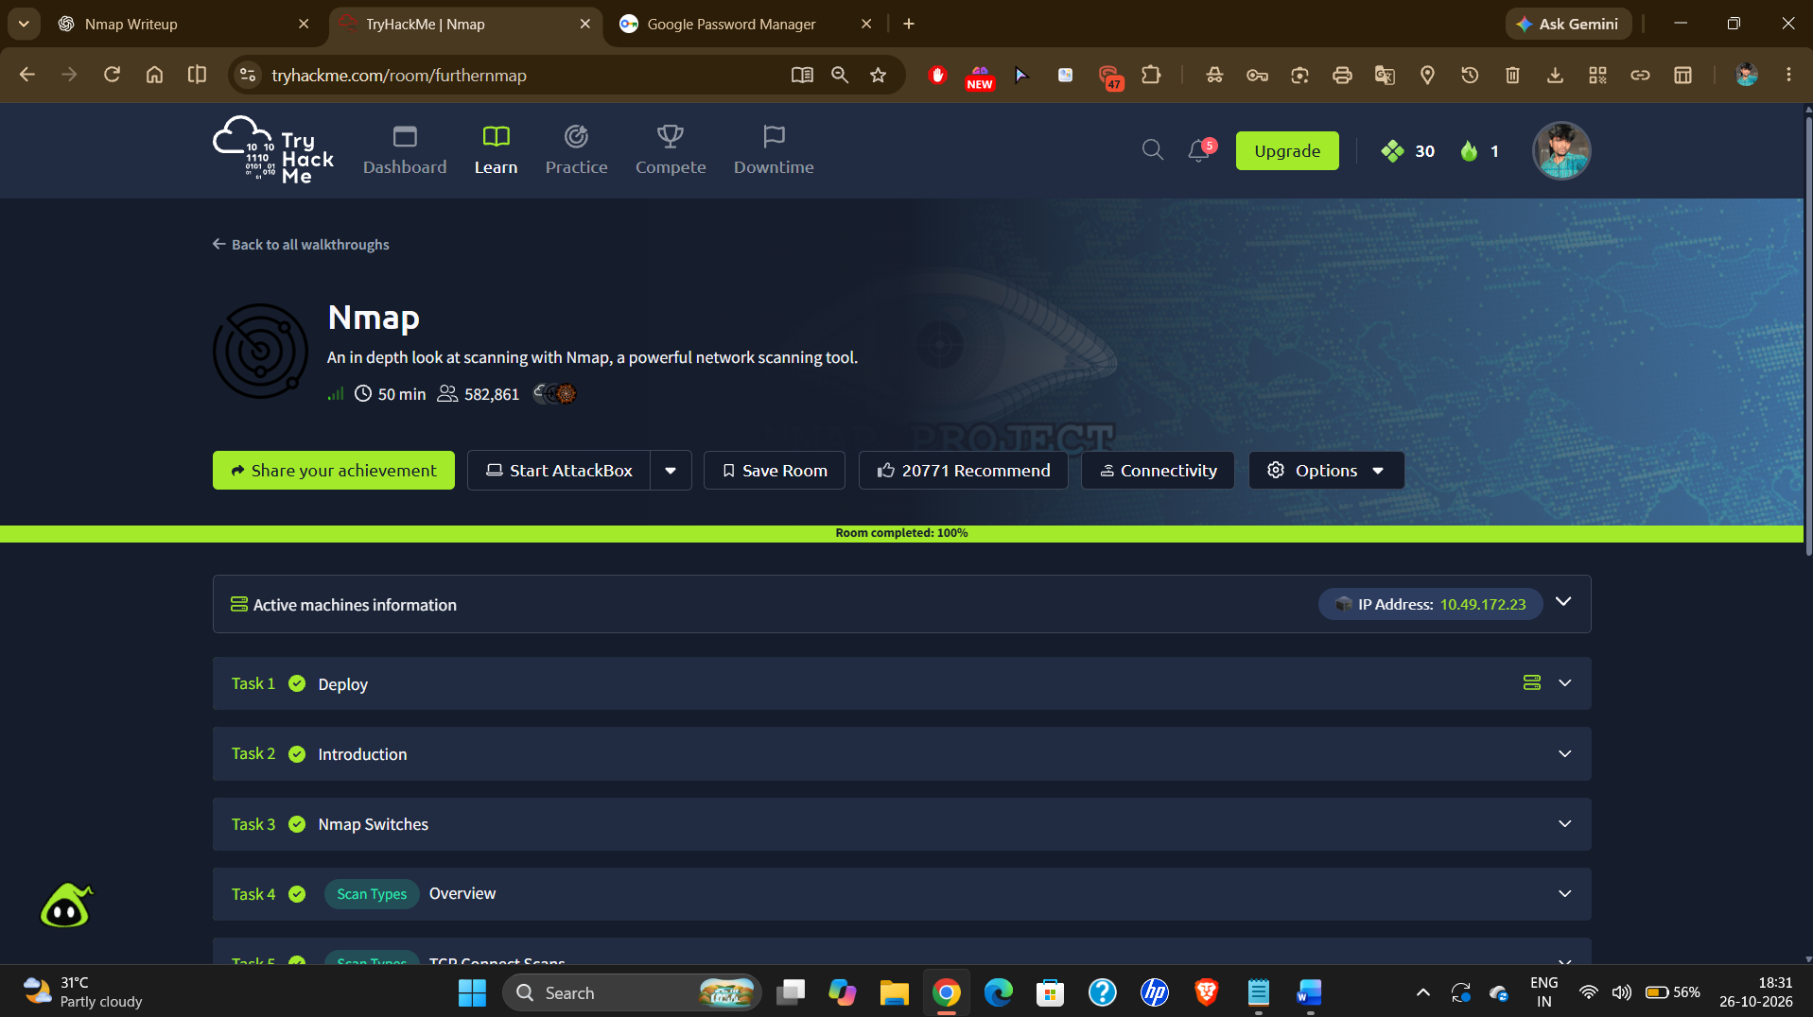
7. Challenges Faced
The main learning challenge was understanding the differences between port states and the purpose of different Nmap scanning options. Reviewing command syntax and learning how to interpret scan output helped clarify these concepts.
This section should be adjusted if your actual experience was different.
8. Conclusion
This exercise provided an introduction to Nmap and network reconnaissance. I learned the purpose of port scanning, service detection, and interpreting port states. These concepts are useful for a SOC Analyst when investigating network activity, identifying exposed services, and supporting security monitoring and incident response.
The exercise also strengthened my understanding of how network reconnaissance relates to defensive cybersecurity practices.

